Fall 2021 Newsletter

Fall Events

The Space Policy Institute returned to in-person instruction in Fall 2021.

The Space Policy Institute hosted “Space Policy Perspectives: Geopolitics, Business Drivers, and Cloud Strategies” on September 22. This virtual event consisted of two distinguished panels that included speakers Jamie Morin of the Aerospace Corporation, Dr. Derek Tournear of the Space Development Agency, Deputy NASA Administrator Pam Melroy, Lindsey Millard of the Office of the Under Secretary of Defense (R&E)r, Hank Tseu of OneWeb, Daniel Brennan of Oracle, Sarah Mineiro of Anduril Industries, and Stephen Marely and Sheryl Olguin of the Aerospace Corporation. Speakers addressed the intersection of cloud strategies and AI/Machine Learning with space policy issues.

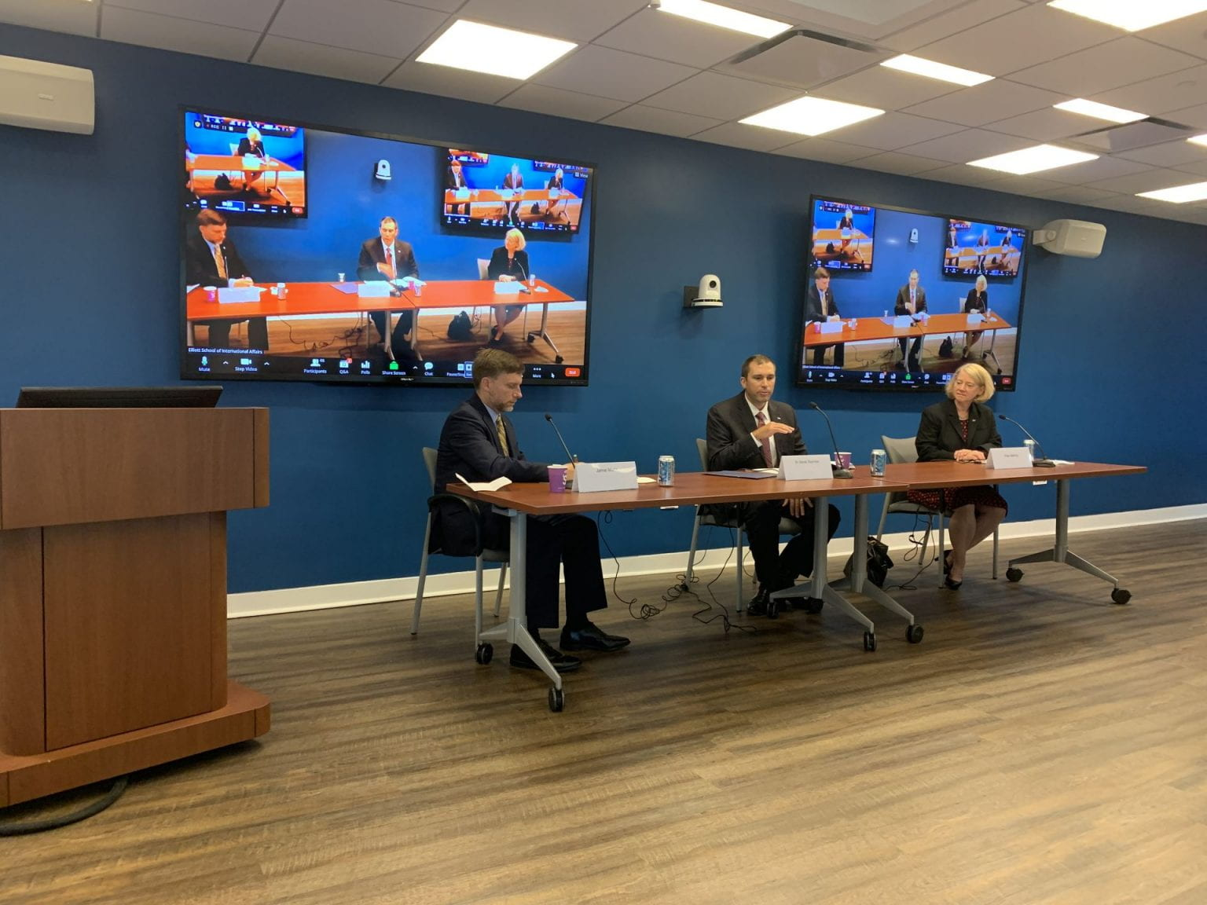

Faculty and Staff News

Research Professor Pascale Ehrenfreund, in her role as President of the International Astronautical Federation (IAF), organized the 72nd International Astronautical Congress 2021 in the United Arab Emirates in October 2021. The space congress gathered more than 5000 delegates from 110 countries in Dubai and was organized together with the Mohammed Bin Rashid Space Centre (MBRSC) under the theme ‘Inspire, Innovate and Discover for the Benefit of Humankind’.

In the fall semester, Prof. Ehrenfreund has given keynote talks at the Space Diplomacy Forum 2021
organized by the Ministry of Foreign Affairs Korea, the Twenty-Seventh Colloquium on High Resolution Molecular Spectroscopy, the Space Forum Luxembourg, the Space & Underwater Tourism Universal Summit in Marbella, the European Conference on Laboratory Astrophysics, the Women in Space International Forum in Beijing, the University College London Space Week, the International Symposium on the Peaceful Use of Space Technology in Beijing and at the International Space University. Furthermore, she served as panel member at the 36th Space Symposium in Colorado and the SpaceTechExpo Europe in Bremen. She participated in the Space Economy Leaders Meeting G20 in Rome in her role as President of the International Astronautical Federation. Prof. Ehrenfreund is a member of the World Economic Forum Global Future Council on Space and serves as President of the International Space University.

Research Professor Henry Hertzfeld had an active and busy schedule during the fall of 2021. He was the faculty advisor to the GW Space Law Moot Court Team that won the North American rounds with 18 other law school teams competing in the Manfred Lachs International Space Moot Court. Prof. Hertzfeld completed a study of innovation in space missions for the World Intellectual Property Organization in Geneva, Switzerland, which will be published this spring. He had the able assistance of two SPI graduate students, Ben Staats and George Leauna on that study. He participated in a virtual panel on space policy at the University of Pennsylvania’s Perry World House, lectured at the Florida Institute of Technology’s summer space policy program, and was also on a panel focusing on Public Private Partnerships at the AIAA ASCEND meeting in Las Vegas. He had an article on the Registration Convention published in the JSSE and his book chapter, on future liability issues connected with planetary defense, was published this past fall. Finally, he continued to be active in the IAF, chairing the Economics Technical Committee, chairing the audit committee for the International Institute of Space Law (IISL) and serving as a member of NOAA ACCRES (Advisory Committee on Commercial Remote Sensing).

Adjunct Professor John. J. Klein returned happily to in-person instruction at the Space Policy
Institute during the spring semester and had 30 students in his undergraduate course “Space in
International Affairs.” During this period, he also supported several national security space wargame planning events. He wrapped up work on his forthcoming chapter “NewSpace and New Risks in Space Security,” for the Oxford Handbook of Space Security (Oxford University Press). Additionally, Prof. Klein is writing the book-length manuscript Small Space Wars: Irregular Warfare and Competition in the Space Domain, and is seeking publication in early 2023.

Professor Emeritus John M. Logsdon continues his involvement with the Space Policy Institute. He made a guest appearance during the Fall 2021 U.S. Space Policy class and promotes SPI in media and public speaking.

Student News

We would first like to congratulate our December graduates. Dillion MacInnis and Kristi Bradford have both graduated with their M.A. and Mariah Baker with a graduate certificate.

During the Fall 2021 and Spring 2022 semesters, space policy students held jobs and internships in many different government agencies and private companies. These included Intelsat, Amazon's Project Kuiper, NASA, The Aerospace Corporation, SpaceX, In-Q-Tel, Smithsonian National Air & Space Museum, Booz Allen Hamilton, SpinLaunch and the House Committee for Science, Space, and Technology, among others.

We would like to congratulate graduate student Joshua Ingersoll for his paper, Bridging the Digital Divide: An Analytical Approach to How Proliferated Low-Earth Orbit(pLEO) Constellations Will Bring Millions of Humans into the Information Age, which was selected for presentation at 2021 IAC in Dubai.

Message From the Director

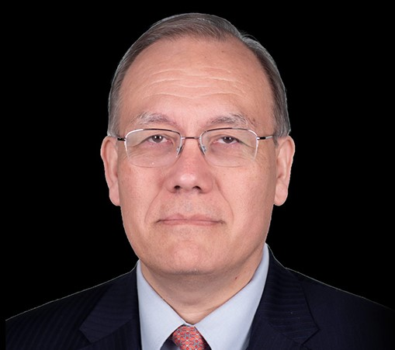
Professor Dr. Scott Pace

Fall 2021 was my second full semester since returning from the National Space Council in January 2021. After teaching fully remote in Spring 2021, it was great to return to in-person classes (albeit masked) in the Fall. We did not give up all our remote teaching tools as from time to time students testing positive would be participating while in quarantine.

We were able to introduce some in-person events with remote support, such as seminars and workshops, as city and university regulations allowed. The GW Chapter of the American Institute for Aeronautics and Astronautics (AIAA) hosted a panel in November with myself, Brendan Curry of the Planetary Society, and SPI alum Cody Knipfer of Virgin Orbit.
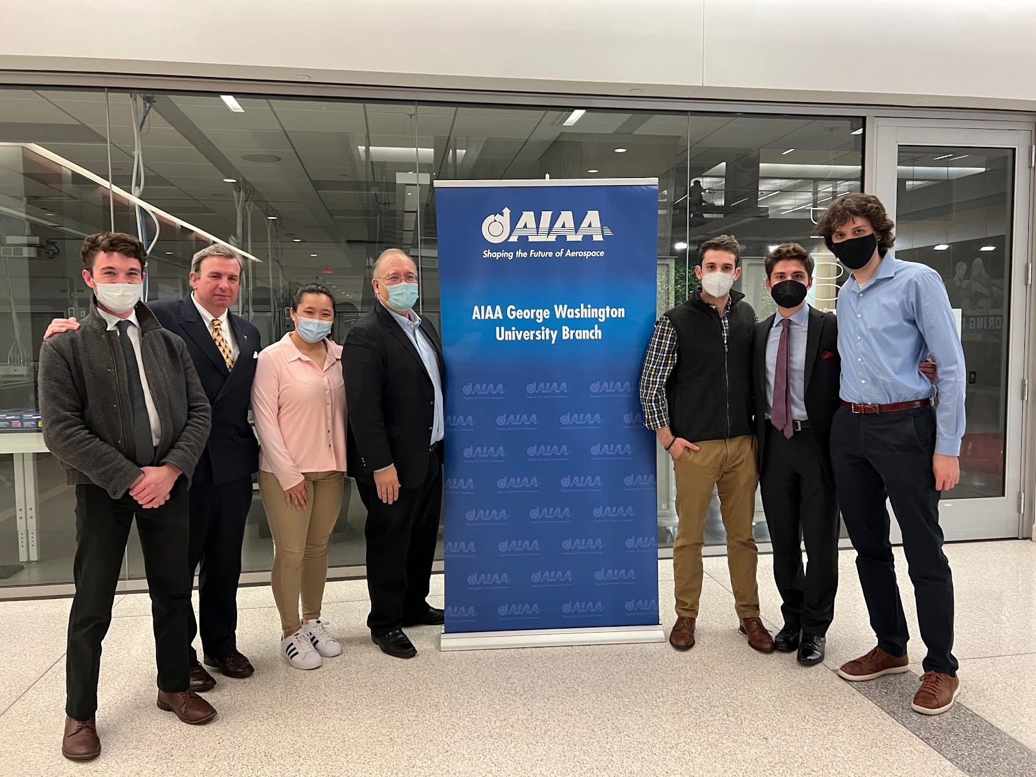

In cooperation with Auburn University, SPI hosted a conversation with General James Dickinson, the Commander of U.S. Space Command, in July. In August, adjunct professor John “Patsy” Klein gave a virtual talk on “Lawfare: the Use of Legal Regimes for Competitive Advantage in Space” with the U.S. Air Force Academy.

My personal engagements and presentations picked up considerably in the fall. Events included talks to classes at Harvard University, the University of Colorado at Boulder, and a NASA leadership training program. I also spoke to federal advisory committees, such as the PNT Advisory Board, on U.S. national space policy and measures to improve GPS resilience. International space governance, prospects for space cooperation with China, and space cybersecurity were my topics for talks hosted by the Secure World Foundation, the Hague Institute for Global Justice, and the Comp-TIA trade association. In academic writing, I completed a chapter on space security and international relations for a new Oxford Handbook on Space Security and submitted an article on the application of international relations theory to space cooperation and competition. I am currently working on paper examining potential patterns of international cooperation in human spaceflight after the end of the International Space Station.

Generous contributions from Amazon Web Services, Axiom Space, and the GPS Innovation Alliance enabled SPI to award eight partial fellowships to deserving graduate. In addition, a generous individual donation from GW alum Michael Thacher allowed us to establish an annual $4,000 prize for an outstanding student publication in space policy. With SPI travel support, two graduate student were able to attend the 2021 International Astronautical Federation meeting in Dubai. Dillon McGinnis presented a paper on swarm robotics in space and Josh Ingersoll presented his work on how proliferated LEO constellations can benefit communications for developing countries. All of us at SPI are deeply grateful for our corporate partners and affiliates who are making life-long differences to our students

Supporters

Our efforts would not be possible without the generosity of our sponsors. We sincerely appreciate the continued support of the following partners:

The Aerospace Corporation
Amazon Web Services
Axiom Space
Boeing
GPS Innovation Alliance
Jacobs Engineering
Limitless Space Institute
Lockheed Martin Corporation
Maxar
Northrop Grumman

Contact Us

The Space Policy Institute
1957 E St NW, Suite 403
Washington, D.C. 20052

spi@gwu.edu
(202) 994-2146
https://spi.elliott.gwu.edu/

